Registration Instructions
- Be sure to turn off any pop-up blockers on your computer before starting registration.
- Be sure to select SP2024 in order to register for spring courses.
- If you get a message that your registration has been canceled, that is not correct. Email the help desk at: support@kwc.zendesk.com
- Advisors must release your registration hold for the SP2024 semester before you can register.
- If you are needing a prerequisite waiver for a course, please contact the instructor of that course and see if they will grant the waiver.
- If you are trying to register for a course and you are currently taking the pre-requisite for that course, you need to email the registrar’s office at: registrar@kwc.edu
- If you are wanting to register for an online course, please use the link below to access the ‘Online Course Registration Form’. Please do not contact the faculty member for permission.
  - Registrar – Kentucky Wesleyan College Intranet (kwc.edu)
- Internships/Practicums/Externships are to be completed through Handshake.
  - Handshake-Contract-Instructions.docx (live.com)

Directions on registration:
Access your student portal using this link:
https://cams.kwc.edu/student/login.asp
Your Login information is the same as your Email and Brightspace Login information.
Change the term to SP2024 when you are signing in.

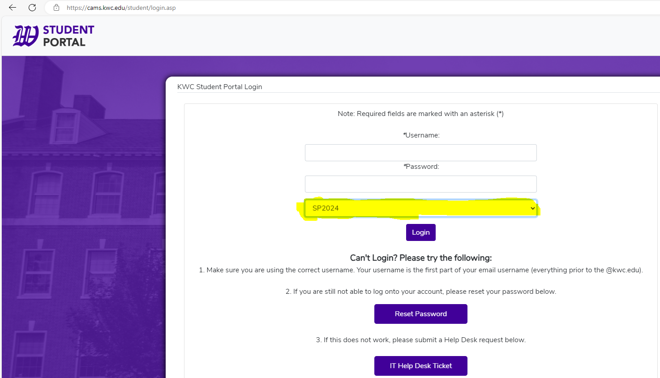
Double Check that you are in the correct term by hovering over the “Profile” tab.
Go to ‘ADMIN’ and click on ‘Registration’.
If you get this message, you need to see your advisor.

The Unofficial Registration page opens with the student’s current schedule displayed at the top of the page. Unofficially registered courses may be dropped by selecting the checkbox next to the appropriate class. Courses available for registration are displayed in the lower portion of the page. The portal compares the student’s transcripts against the course offering, and if pre-requisites for a course have not been met, the course will not display. If a waiting list is available, the student may put themselves on it by registering for the course.

Click Show Filter to expand the Course ID Filter section.
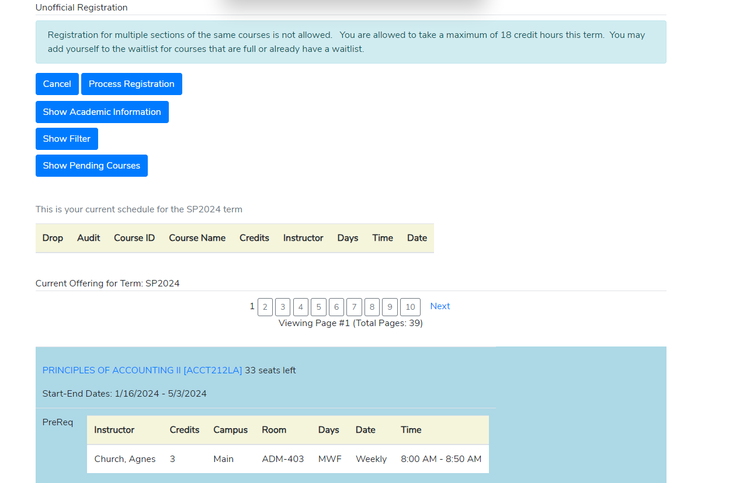

After clicking the Show Filter button, this will pop up.
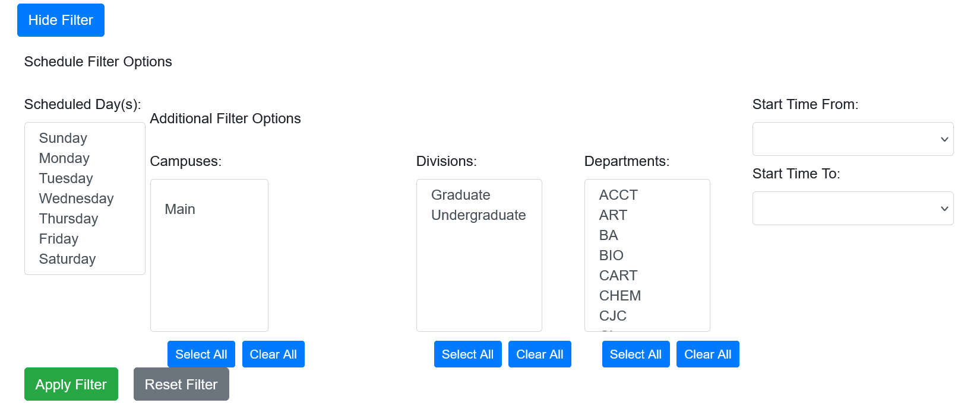
You can pick which department your classes are in and can also specify when these classes start or what days they are on.
After applying your specific filter, the courses that meet those requirements will pop up like so:
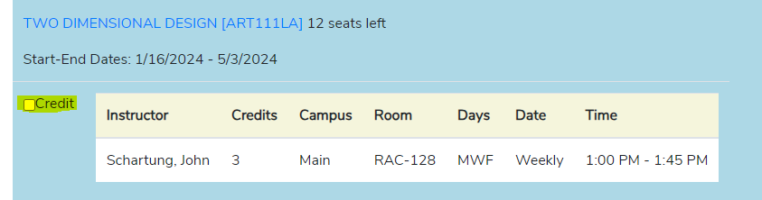
Just click the ‘CREDIT’ box to add a course.
If you need to drop a course. Click in the box next to the course.
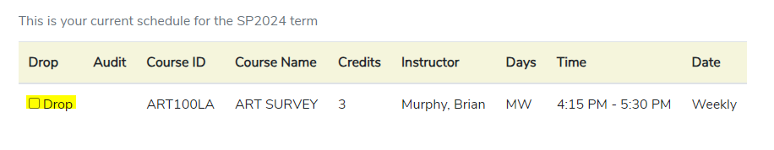
Once you have selected all the courses you wish to register for, click Process Registration in the top right corner or at the top of the page.
Students you may see these codes: • Reg – The student is already registered for the course.
• FacAppReq –The Instructor’s permission is required. Only the Registrar can register this course. Email the registrar at: registrar@kwc.edu
• PreReq – Prerequisite has not been met. If you are currently in the pre-requisite for this course email the registrar at: registrar@kwc.edu
• CoReq– this course has a co-requisite that you must register for with this course. Example: Course with a lab. BIO105 Concepts in Biology and BIO106 Concepts in Biology Laboratory. You need to select both courses before processing registration.
• Last Add – The date is past the date this course may be registered.
• Class is Full – The course is full.
• Waitlist – The course has a waitlist and, if enabled, students may only select the Waitlist check box to place themselves on the waitlist for this course.

Click the course link to open a pop-up window with further details such as Co-Requisites, Pre-requisites, and Equivalents.

Upon processing registration, if you are not registered for a required corequisite course, a warning prompt will appear, and registration cannot continue until the corequisite course is selected. If you have not already met a corequisite in a previous term, a notice will display indicating the corequisite has already been met. A warning prompt will also be displayed when dropping a course that is needed as a corequisite.

