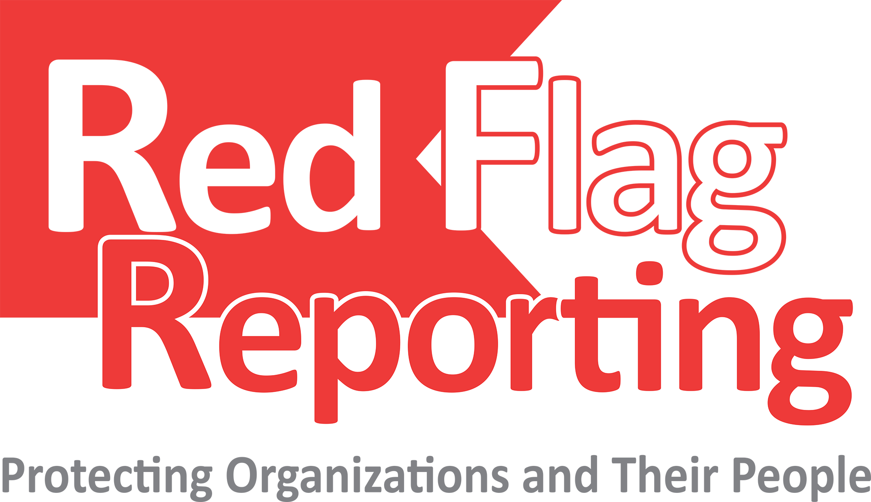







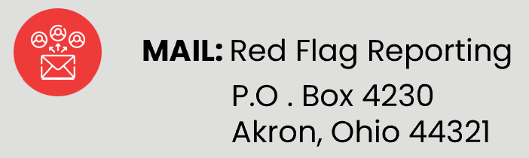


KYWC

Report concerns safely, securely, and anonymously 24/7
If you are uncomfortable with a situation, be proactive.
Red Flag Reporting is your hotline for reporting unethical, unsafe, and/or fraudulent activity.

Protect Your Coworkers and Your Organization!
Click on “File a Report” and Use Client Code:
To file a report, pick one of the following options and use the client code noted below:

