9.13.18

Jefferson County Public Schools (JCPS) has a number of positions for which we are seeking additional applicants. JCPS does have transition incentives available. Depending on the distance to relocate, a new hire may receive up to $4,000. We have the following openings:

•35 Special Education
•10 Elementary School
•6 Middle and/or High School English Language Arts
•28 Middle and/or High School Math
•16 Middle and/or High School Science
•12 Middle and/or High School Social Studies
•10 Early Childhood
•3 Art
•1 Music
•9 Career Technical
•2 Health/PE

Please share this information with your recent graduates, career placement offices or others who may be interested.

Interested candidates are encouraged to apply at:
https://www.applitrack.com/jefferson/onlineapp/

The City of Owensboro is taking applications for the following positions: TELECOMMUNICATOR & CALLTAKER In the Central Dispatch Unit at the Owensboro Police Dept. MANDATORY TESTING - October 4 & 5, 2018 Applicant will be assigned a testing session on one of these dates. Test notices with further information and assigned testing session will be mailed to applicants. Minimum Education/Experience Requirements: Telecommunicator - Requires High school diploma or G.E.D. Associates Degree preferred but not required. Requires strong attention to detail, computer, and communication skills, and ability to deal with stressful situations. Must type at least 30 words per minute and have a valid driver’s license (i.e., to attend training). Calltaker - Requires High school diploma or G.E.D. Requires strong attention to detail, computer, and communication skills, and ability to deal with stressful situations. Must type at least 30 words per minute and have a valid driver’s license (i.e., to attend training). Telecommunicator Job Summary: Qualifications include but are not limited to, being able to effectively communicate in person and by phone/radio, use hands to finger/handle/feel, reach with hands and arms, lift/move up to 25 pounds, stand/walk/stoop/kneel/crouch/crawl on occasion when necessary, sit for long periods of time, perform repetitive motion (i.e. using computer keyboard, radio equipment, foot pedal, etc), use vision to see close, distance, color, peripherally, depth perception, and/or ability to adjust focus, effectively use office and dispatch equipment, such as but not limited to, multi-channel two-way radio, multi-line telephone systems, CAD system, Fire Log, LINK/NCIC terminal, TDD equipment, and other requirements as stated in the job description. This a full-time, non-civil service position in the Central Dispatch Unit. Work hours are generally 8 hour days (40 hours a week). Overtime may be required as needed. Shift work required, including weekends and holidays. Travel required (for training purposes, etc.). Initial training period consists of 4.5 weeks in Richmond, KY at the Academy. This is a full time position. Calltaker Job Summary: Qualifications include but are not limited to, being able to effectively communicate in person and by phone/radio, use hands to finger/handle/feel, reach with hands and arms, lift/move up to 25 pounds, stand/walk/stoop/kneel/crouch/crawl on occasion when necessary, sit for long periods of time, perform repetitive motion (i.e. using computer keyboard, radio equipment, foot pedal, etc), use vision to see close, distance, color, peripherally, depth perception, and/or ability to adjust focus, effectively use office and dispatch equipment, such as but not limited to, multi-channel two-way radio, multi-line telephone systems, CAD system, Fire Log, LINK/NCIC terminal, TDD equipment, and other requirements as stated in the job description. This is an intermittent (part-time), non-civil service position assisting in the Central Dispatch Unit. Work hours are generally less than 100 hours per month on average. Shift work required, including weekends and holidays. Travel required (for training purposes, etc.). This is an intermittent (part time) position. Compensation and Benefits. Pursuant to applicable policy, with minimum starting pay as follows: Telecommunicator: $16.3117/hour + eligible for the City of Owensboro benefit package Calltaker: $12.00/hour, excepted as mandated, there are no benefits TO APPLY: In order to be considered for October test dates, your application must be received by 10:00 pm, September 21, 2018. To apply, visit www.owensboro.org/police or www.owensboro.org and click on Employment Opportunities, then click on the position you are interested in and follow instructions. If you have any questions or want to confirm receipt of your application, please contact Jo Hall at 270-687-8861 before September 20, 2018. The City of Owensboro is an Equal

8.31.18 Timesavers is hiring.
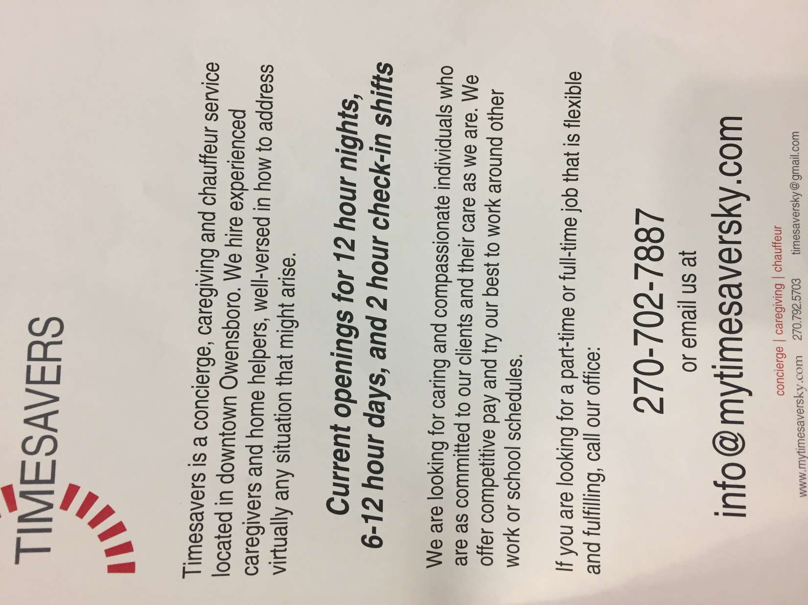

______________________________________________________________________________
8.31.18
Earle C. Clements Job Corps Academy
2302 U. S. Hwy. 60 East
Morganfield, KY 42437

__________________________________________________________________________________
8.28.18

Contact Richard Moore rmoore@luthanmeter.com

625 Birkhead Ave
Owensboro, KY 42303
Shop: 270-683-2474

_____________________________________________________________________________________
8.28.18
Database Administrator
Kentucky Wesleyan College seeks applicants for a full-time Database Administrator in Information Technology Services (ITS) to maintain institutional databases and supporting applications.

Major Responsibilities
- Managing college databases, including but not limited to:
  - Maintaining updates as needed.
  - Designing, implementing, and maintaining database and operating system security for client and server configuration.
  - Evaluating and optimizing database configuration and access.
  - Resolving database performance and capacity issues.
  - Working with end user to fix bugs.
  - Planning for capacity and growth of new and ongoing systems.
  - Developing, maintaining, and updating data dictionaries and other database documentation.
- Serving as liaison for servers not directly supported by ITS.
- Cross training with other ITS staff to provide support in other areas.

Qualifications
- At least three years of experience as a database administrator.
- Associate or technical degree in a computer-related field.
- Knowledge of Visual Basic, Microsoft SQL Server, database structures, Microsoft Office, and Crystal Reports or equivalent ODBC query tool.
- Ability to communicate with users on their level.
- Ability to prioritize multiple tasks and work with distractions.
- Must be a self-started and able to work with little supervision.

Employee Benefits
This full-time position has access to a full range of employee benefits, including health, dental, vision, and life insurance; retirement plans; tuition plans; and a generous benefit time program.

Due to the college’s not-for-profit status, employees of Kentucky Wesleyan may be able to receive loan forgiveness under the Public Service Loan Forgiveness Program of the US Department of Education.

Application Process
Please submit a cover letter, resume, and the contact information for three professional references to Cindy Sublett in Human Resources at csublett@kwc.edu. Applicants will receive an email confirming receipt of materials. Kentucky Wesleyan College is an equal opportunity employer.

Review of application materials will begin September 5. Applications accepted until the position is filled.

An official transcript for the highest degree awarded will be required of the successful candidate, as will a background check. The College will not sponsor applicants for work visas.
__________________________________________________________________________________
8.27.18

Kentucky Career Center
3108 Fairview Drive
Owensboro, KY 42303

_________________________________________________________________________________
8.24.18
Earle C. Clements Job Corps Academy
2302 U. S. Hwy. 60 East
Morganfield, KY 42437

_______________________________________________________________________________________
8.24.18
Details: Sales Marketing Consultant
Make your mark in Broadcasting and Digital Media. Sinclair Broadcast Group and Sinclair Digital Solutions are dedicated to making Sinclair a communications powerhouse! We are the largest and most diversified television broadcasting company in the country. Sinclair owns and operates, programs or provides services to more television stations than anyone and has affiliations with all the major networks. Sinclair Digital group is focused on bringing the most engaging content to web, mobile and over-the-top broadcasting to audiences all over the country! Our success is the result of extraordinary employees and an exemplary management team who believe in a vision and are dedicated ensuring a great future for our employees. Whether you are an industry veteran or a just starting out, you can find it at Sinclair! We are advancing the world of Broadcasting and we want YOU to join our winning team!
WDKY-TV is seeking an enthusiastic, highly motivated Marketing Consultant who can connect with clients and help them achieve their business objectives through effective TV and digital advertising. The ideal candidate will possess excellent communication skills, have an enthusiastic and outgoing personality, and a drive to succeed. Most importantly - we are looking for a hard-working salesperson who wants to have FUN at work, make money, and help local businesses grow.
In this position, you will: Generate revenue for the station and meet monthly goals through effective outside sales techniques
- Develop new business through selling advertising time, digital solutions and other station products by reaching out to local businesses and other advertisers
- Create and present advertising strategies and ideas for local businesses incorporating TV, online and digital mediums
- Provide input on sales promotion ideas to sales management
- Retain current business and develop new business contacts
- Attain budgeted revenue goals through effective solicitations, promotions and service
- Understand the business objectives and advertising strategies of clients and find ways to help them achieve their objectives through effective advertising

Vacancy Type: Full Time
City:
Lexington - 40502
State:
Kentucky
URL:
http://www.wdky.com
Experience:
- Media sales experience preferred and an excellent understanding of TV and media plans, the local advertising marketplace, and key competition
Requirements: The ideal candidate will have the following skills:
- Positive mindset and a Passion for contributing to a sales team
- Driven by practical results, opportunities to learn, and opportunities to assist others
- Effective relationship building, customer service, communication and negotiation skills
- Superior business acumen related to new media, digital interactive initiatives and social media required
- Ability to quickly recover from adversity
- Ability to effectively communicate, build rapport and relate well to all kinds of people
- Professional appearance a must
- Reliable transportation and a satisfactory driving record
- Strong organizational, written and presentation skills
- Proficient in Word, Excel and PowerPoint
- Ability to build and maintain positive customer relationships
- Competitive, persuasive, energetic and self-motivated traits
- Ability to overcome objections
- Working knowledge of new media, digital interactive initiatives and social media required
- Outside media sales experience preferred but not required
- Enjoy a fast paced environment with a desire to win
Professional appearance a must
Additional Information:
Our Marketing Consultants are some of the highest commissioned sales people in the industry. If you are interested in selling some of the best media in the industry, we want to hear from you!
Sinclair Broadcast Group, Inc. is proud to be an Equal Opportunity Employer and Drug Free Workplace!
Contact:
Sinclair Broadcast Group is proud to be an Equal Opportunity Employer and a Drug Free Workplace.
Please apply online by going to: http://sbgi.net/sbgi-careers/

__________________________________________________________________________________
8.22.18

Kentucky College Coaches AmeriCorps program and we need more candidates for our 18-19 Breckinridge Co HS spot.

__________________________________________________________________________________________
8.22.18 TTMA has an open position for a Temporary Cost Reduction Tracking (CRT) Clerk. This will be an office position with hours of 8a-5p, Mon-Fri (potential for some Saturdays) . While the hours are listed 8-5 TTMA is willing to work around the candidates class schedule.
The starting pay rate will be $11.50. At this time, the position is anticipated to last approximately 6 months; however, this may be subject to change.

TTMA is looking for a candidate that preferably has an accounting background and/or is strong with numbers; this individual will need to have proficient skills with Microsoft Excel and will be asked during the interview to complete an Excel Skill Test.

If you feel that you are a qualified candidate please email your resume to Chyna Kelton ckelton@ttna.com

Responsibilities include, but are not limited to:
- Maintain data and documentation related to cost reduction strategies (graphs, excel spreadsheets, etc.)
- Monitor improvement activities and follow up to ensure deadlines are met per supervisor’s direction.
- Track progress of cost reduction activities.
- Update spreadsheets and CRT information in the CRT room.
- Promote kaizen (continuous improvement) activity.
- Other duties assigned by CRT Management.

Technical Competencies:
- Proficient with Microsoft Office; in particular, Excel. Must be able to use pivot tables, power pivot, create graphs, spreadsheets and formulas.
- Strong mathematical aptitude and ability to work accurately with numbers.
- Ability to read and interpret kaizen suggestion forms and graphs
- Proficient computer skills with Microsoft office, personal computer and system software skills to accomplish worksheets, etc.
- Ability to read with understanding and interpret work instructions.

Thanks,

Chyna Kelton
Human Resources Specialist
Toyotetsu Mid America (TTMA)
3100 Airpark Drive
Owensboro, KY 42301

Desk # (270) 852-1732

_____________________________________________________________________________________
8.21.18

Hiring a paralegal

_______________________________________________________________________________________
8.21.18 Admissions Processing Coordinator

Kentucky Wesleyan College seeks applicants for an Admissions Processing Coordinator. This is a full-time, year-round position working in the Office of Admissions and Financial Aid.

Major Responsibilities
- Assisting with reception duties (e.g., processing phone calls, greeting and assisting visitors).
- Performing data entry, data management, and data file imports into the software system.
- Maintaining data integrity by performing regular review and data clean-up.
- Processing incoming mail (e.g., opening, date stamping, sorting, and distributing) and outgoing mail projects.
- Processing student credentials and decision letters in application files and entering receipt of documents into the software system.
- Responding to requests for admissions data.

Qualifications
- College degree (bachelor’s preferred).
- At least three years of data entry and/or data management experience.
- Excellent computer, organizational, and communication skills.
- Self-motivated.
- Able to work well under tight guidelines and in a busy environment.

Employee Benefits
This full-time position has access to a full range of employee benefits, including health, dental, vision, and life insurance; retirement plans; tuition plans; and a generous benefit time program.

Due to the college’s not-for-profit status, employees of Kentucky Wesleyan may be able to receive loan forgiveness under the Public Service Loan Forgiveness Program of the US Department of Education.

Application Process
Please submit a cover letter, resume, and the contact information for three professional references to Cindy Sublett in Human Resources at csublett@kwc.edu. Applicants will receive an email confirming receipt of materials. Kentucky Wesleyan College is an equal opportunity employer.

Review of application materials will begin immediately and will continue until the position is filled.

___________________________________________________________________________________
8.20.18 Wendell Foster Center is hiring:
Candidates apply on website (www.wendellfoster.org) which links to Indeed.

Speech Language Pathologist

JOB SUMMARY:
The Speech Language Pathologist evaluates and establishes a plan of care for intervention to be provided through direct treatment.

CLIENT SUPPORT FUNCTION:
The Speech Language Pathologist supports the mission of WF through empowering people by giving them the means to determine and communicate their wants, needs, feelings, ideas and dreams. The Speech Language Pathologist also helps people reach their maximum potential in life by achieving, restoring and retaining swallowing skills to improve quality of life.

QUALIFICATIONS:
Education and/or Experience:
- Master’s Degree in Communication Disorders/Speech Pathology and Kentucky Licensure as required by the Kentucky Board of Examiners for Speech/Language Pathology and Audiology.
- Certificate of Clinical Competence in Speech-Language Pathology as required by the American Speech-Language Hearing Association
- Assisted Technology Professional (ATP) and vital stem certification, preferred

Knowledge, Skill and Abilities:
- Ability to work with individuals with disabilities.
- Ability to work effectively with related professionals.
- Ability to keep technical and professional records and to make appropriate recommendations.
- Possess basic computer skills and ability to learn specialized software.
- Ability to drive campus vehicles, including possession of valid driver’s license and insurable driving record.

Physical Therapist

JOB SUMMARY:
The Physical Therapist recommends and provides or ensures the provision of quality Physical Therapy intervention for individuals served.

CLIENT SUPPORT FUNCTION:
The Physical Therapist supports the mission of WF by providing high quality services and access to equipment that help individuals to restore and maintain their highest level of functioning in order to achieve their goals and dreams. The Physical Therapist also provides education to individuals and families, which promotes independence and hope for the future.

QUALIFICATIONS:
Education and/or Experience:
- Graduate of a Physical Therapy Program accredited by the American Physical Therapy Association and licensed by the Kentucky State Board of Physical Therapy.
- Experience working in ICF-MR/DD settings is preferred.

Knowledge, Skill and Abilities:
- Must be able to accurately communicate information pertaining to an individual’s condition.
- Basic computer word processing skills and ability to learn a software package.
- Ability to drive campus vehicles, including possession of valid driver’s license and insurable driving record.

______________________________________________________________________________________
8.20.18

The Louisville FBI Applicant Team is excited to announce that applications
for our 2019 Student Programs will be accepted August 24 - October 14, 2018!

The FBI offers internships and entry-level positions in a wide range of disciplines to students of all backgrounds. Our unique opportunities offer students from all walks of life a head start in a career like no other!

Detailed information on our Student Programs may be found using the links below.

Please click here for information on the Honors Intern Program and Collegiate Hire Initiative

Please click here to review Employment Eligibility requirements

So, what does the FBI Internship actually look like? Click here to see the kick off of the 2018 program!

Apply online at www.FBIjobs.gov

Information on the Special Agent and Intelligence Analyst position, as well as other Specialized/Professional career opportunities, may be found on FBIjobs.gov.

Questions about employment with the FBI? Email us at LouisvilleApplicants@ic.fbi.gov

_____________________________________________________________________________________
8.17.18

Alumni!

https://www.linkedin.com/jobs/view/785151719/

Grant Dunivan
Manager of Dedicated Operations at Transco Lines, Inc.

Address 60 Transco Park Drive, Russellville, AR 72802
Office 913-233-5694 Mobile 479-276-7911 Email grant.dunivan@transcolines.com
Website www.transcolines.com
____________________________________________________________________________________
8.17.18

Earle C. Clements Job Corps Academy
2302 U. S. Hwy. 60 East
Morganfield, KY 42437

_______________________________________________________________________________________
8.15.18
We are excited to offer an exciting temp to possible perm opportunity to work as a 3rd shift Lab Technician in a coal analysis laboratory located in Henderson, KY. If you have a strong interest in science or high school entry level chemistry and consider your self-detailed as well as reliable this could be a great opportunity to connect with a local but global organization!! Pay Rate: $11.50 hour - Hours: 10:30p to 7:30a Sunday night through Friday morning - Weekend rotation: Sat and Sunday noon to 6p

Email your resume to:

Tina Sullenger
Recruiter
E-mail: tins924@kellyservices.com
Evansville: 812.423.8080
Henderson: 270.826.1140

________________________________________________________________________________
8.13.18
Earle C. Clements Job Corps Academy
2302 U. S. Hwy. 60 East
Morganfield, KY 42437

_____________________________________________________________________________
8.13.18

Kentucky Career Center
3108 Fairview Drive
Owensboro, KY 42303

__________________________________________________________________________
8.9.18
Daviess County Sheriff's Office

***********Accepting Applications for Deputy Clerk**************

$12.88 / hour Full-time

Only applications found on our website will be accepted at:

https://www.dcsdky.com/…/193…/Application_For_Employment.pdf

The Daviess County Sheriff’s Office is currently accepting applications for a full-time Deputy Clerk in the Tax/Administrative division. The applicant should possess:

• High School Diploma or GED; college degree preferred
• Customer service experience a plus
• Ability to use phone and computer systems
• Excellent oral and written communication skills
• Strong listening/comprehension skills

Job Responsibilities:
Tax collection, data entry, answering telephone calls, vehicle inspections, managing civil process

The applicant will undergo a thorough background check and drug screen.

Starting Salary is $12.88 per hour
Paid Holidays/Vacation/Sick Time
Health Insurance

Application can be found at:
https://www.dcsdky.com/…/193…/Application_For_Employment.pdf

The application can be hand delivered during business hours Mon-Fri 8:00 AM to 4:30 PM;

Mailed to:
Daviess County Sheriff’s Office
Attn: Major Barry Smith
212 St. Ann St.
Owensboro, KY 42301

Or emailed to:
bsmith@daviesskysheriff.us

_____________________________________________________________________________
8.7.18 The City of Owensboro is accepting applications for the position of Police Officer.

_____________________________________________________________________________________
8.7.18
The following department has announced that it is recruiting:
Chicago Police Department
Chicago, IL
Starting Salary: $48,078 ($72,510 after 18 months)
Application Deadline: 10/1/18
This is just one of over 335 listings currently available to our members.
For access to The Blue Line 24/7 "Members Only" Area and all of the listings
please visit: www.theblueline.com/subscribe.html
________________________________________________________________________________
8.6.18

Kentucky Career Center
3108 Fairview Drive
Owensboro, KY 42303

____________________________________________________________________________________
8.6.18
Earle C. Clements Job Corps Academy
2302 U. S. Hwy. 60 East
Morganfield, KY 42437
__________________________________________________________________________________
8.2.18 Newcomb Oil-FiveStar is hiring!

They can also Text FIVESTAR to 58046 to see open positions in their areas.

______________________________________________________________________________________
8.1.18

Kentucky Career Center
3108 Fairview Drive
Owensboro, KY 42303
_________________________________________________________________________________
8.1.18
Earle C. Clements Job Corps Academy
2302 U. S. Hwy. 60 East
Morganfield, KY 42437

_____________________________________________________________________________________

